CRETERION IV: INFRASTRUCTURE & LEARNING RESOIURCES
Metrics 4.1- PHYSICAL FACILITIES
4.1.2: The Institution has adequate facilities for cultural activities, sports, games (indoor, outdoor), gymnasium, yoga centre etc.

ATHLETICS NON-STANDARD TRACK | 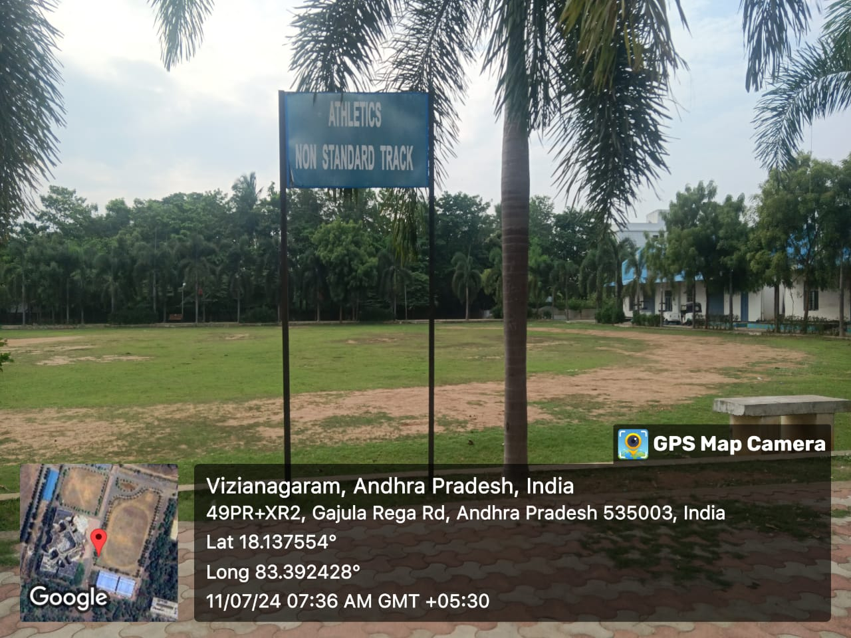
BADMINTON -BOYS | 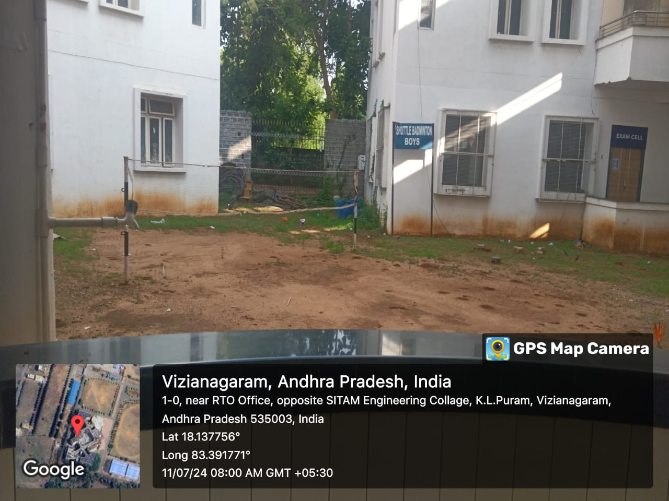
BADMINTON GIRLS | 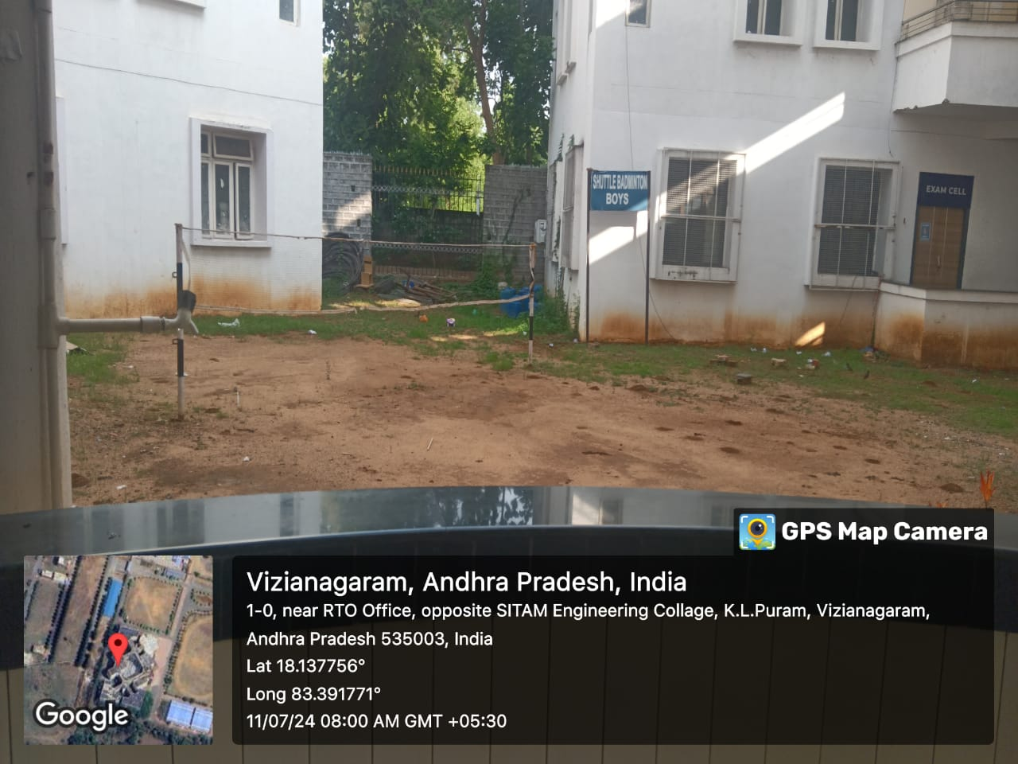
BROAD JUMP PIT | 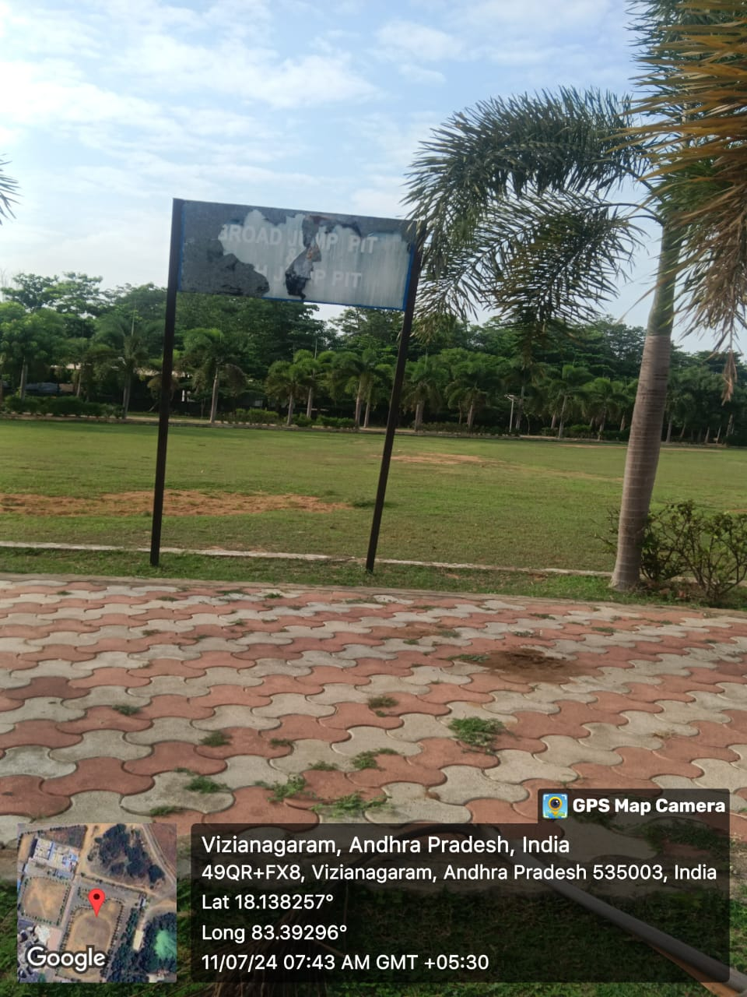
CARROMS | 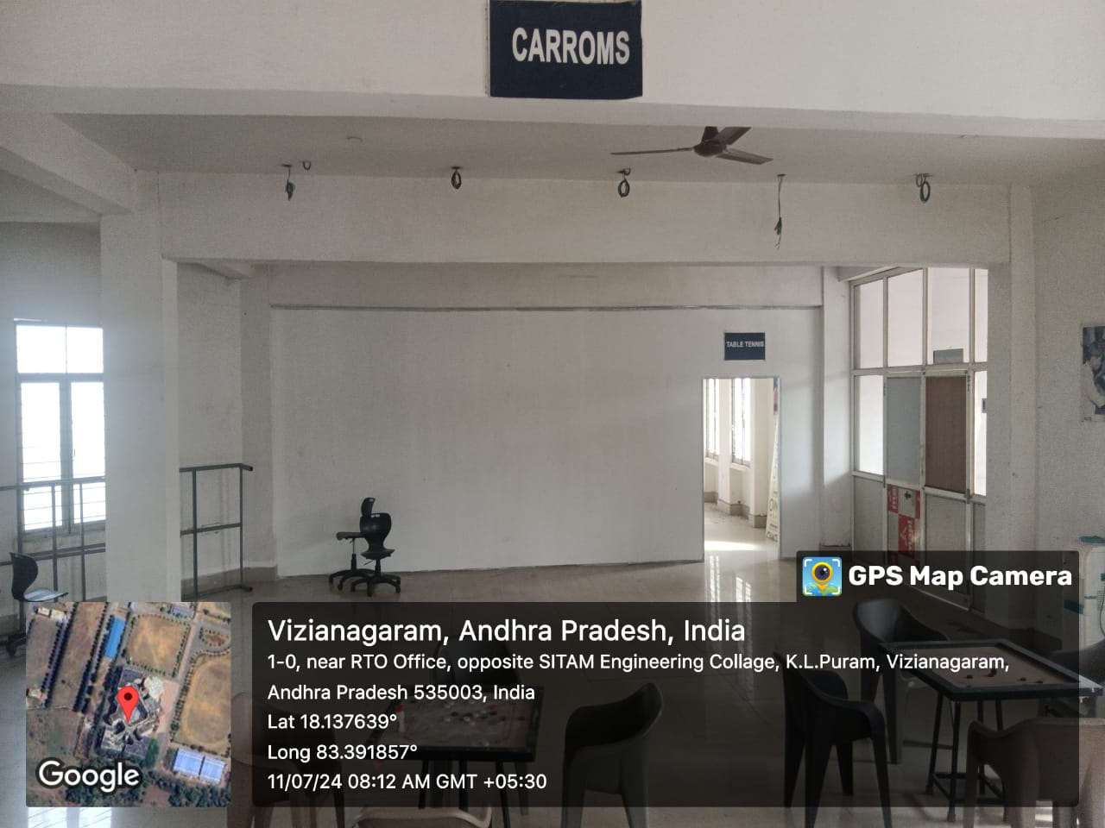
CHESS | 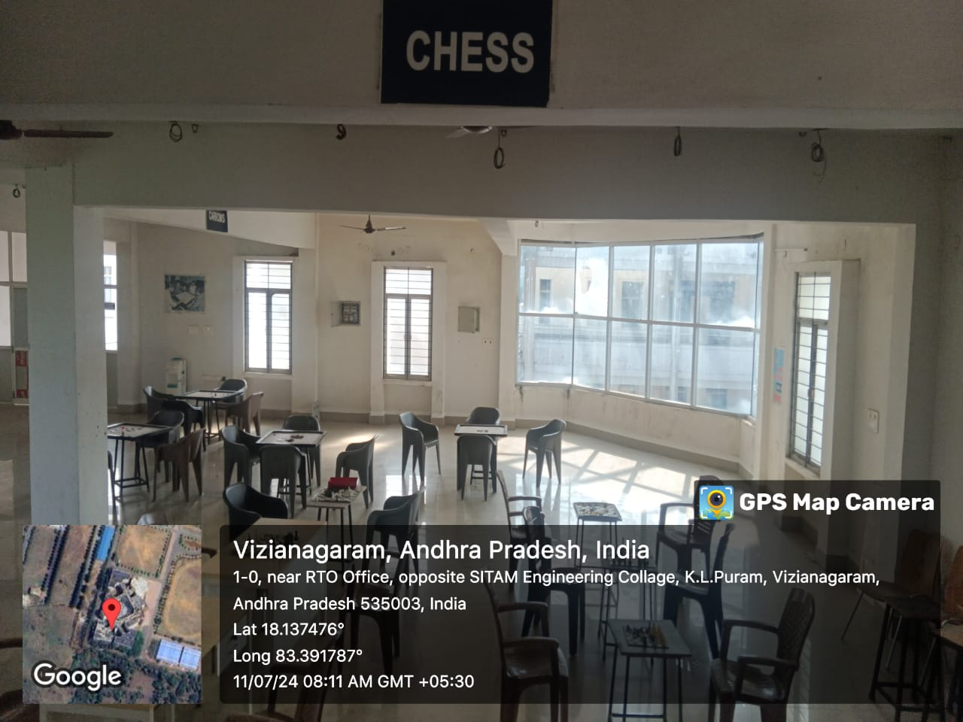
CRICKET | 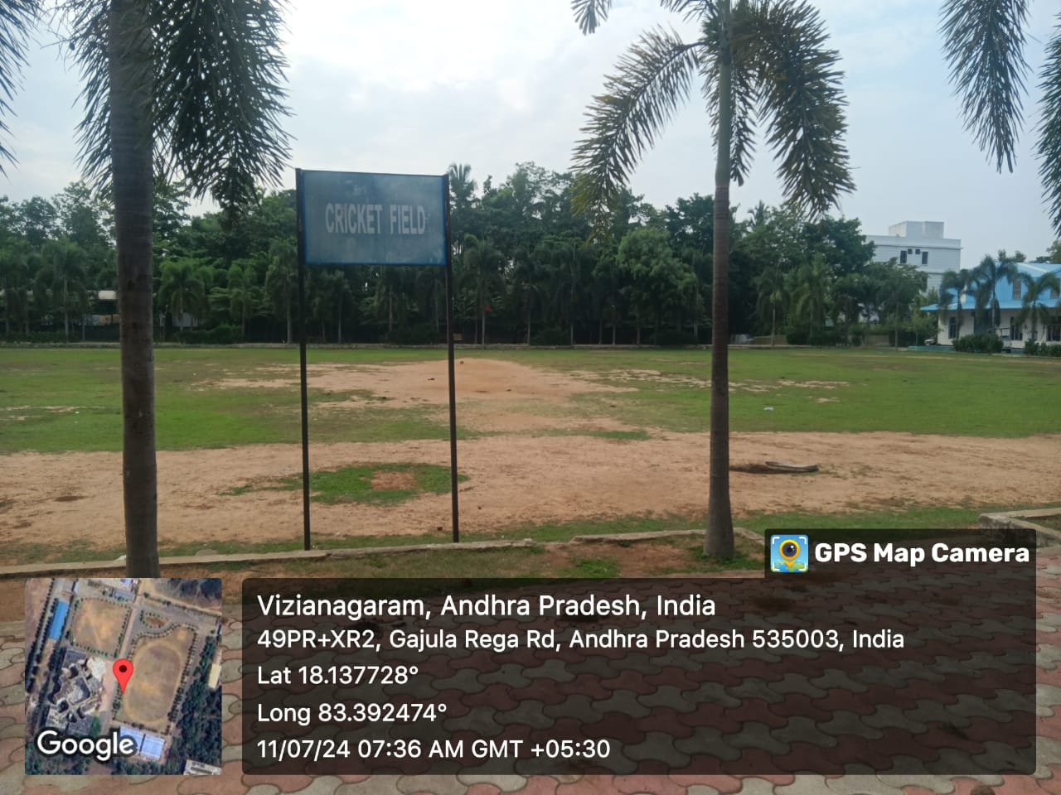
INDOOR CULTURAL | 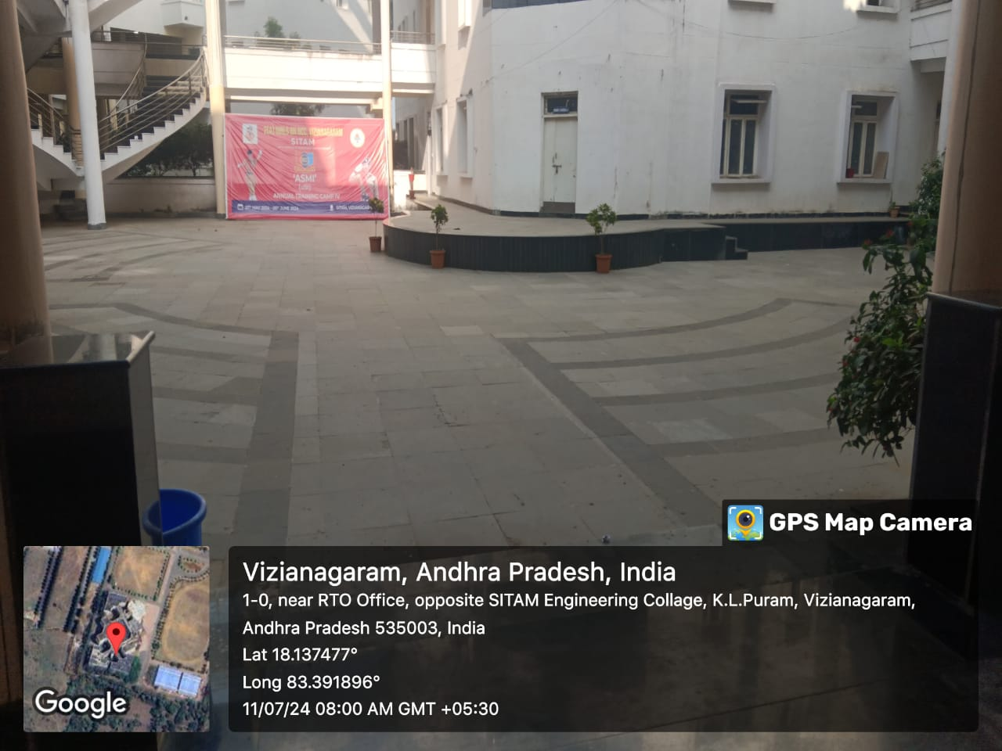
DEPARTMENT OF PHYSICAL EDUCATION | 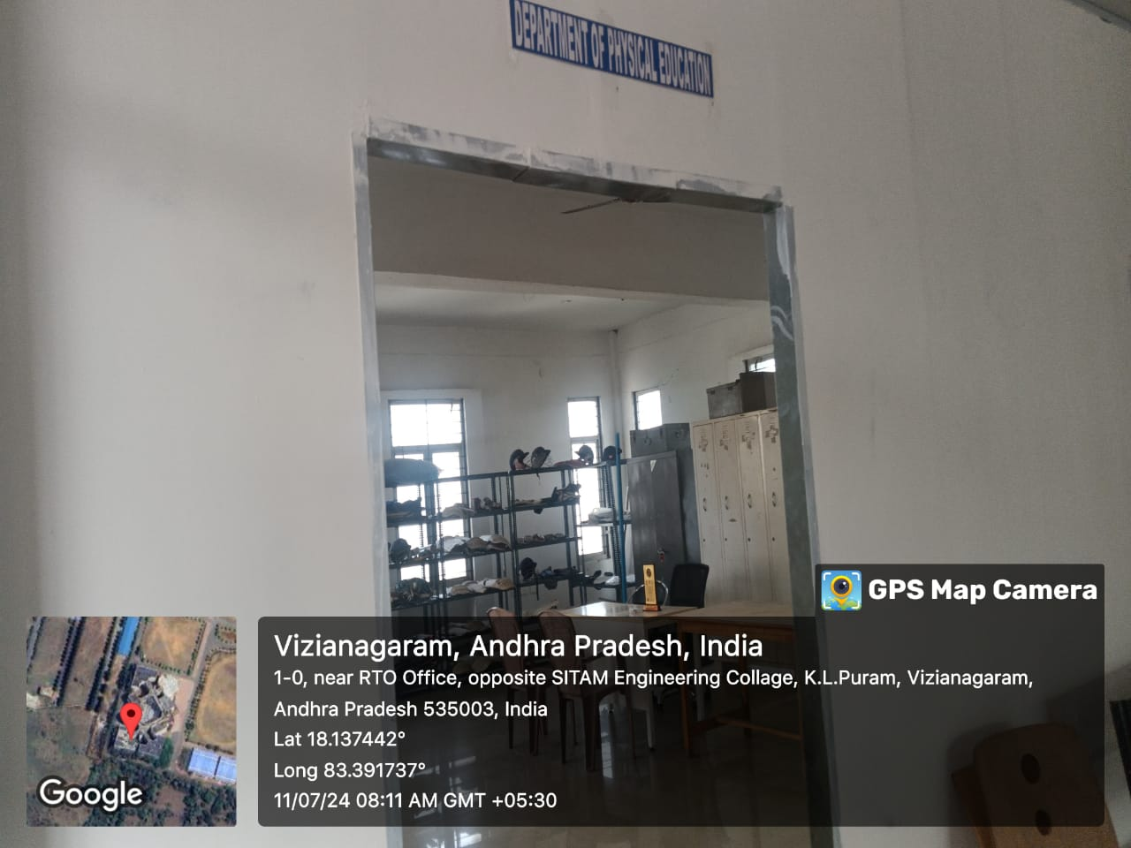
GHOSALA | 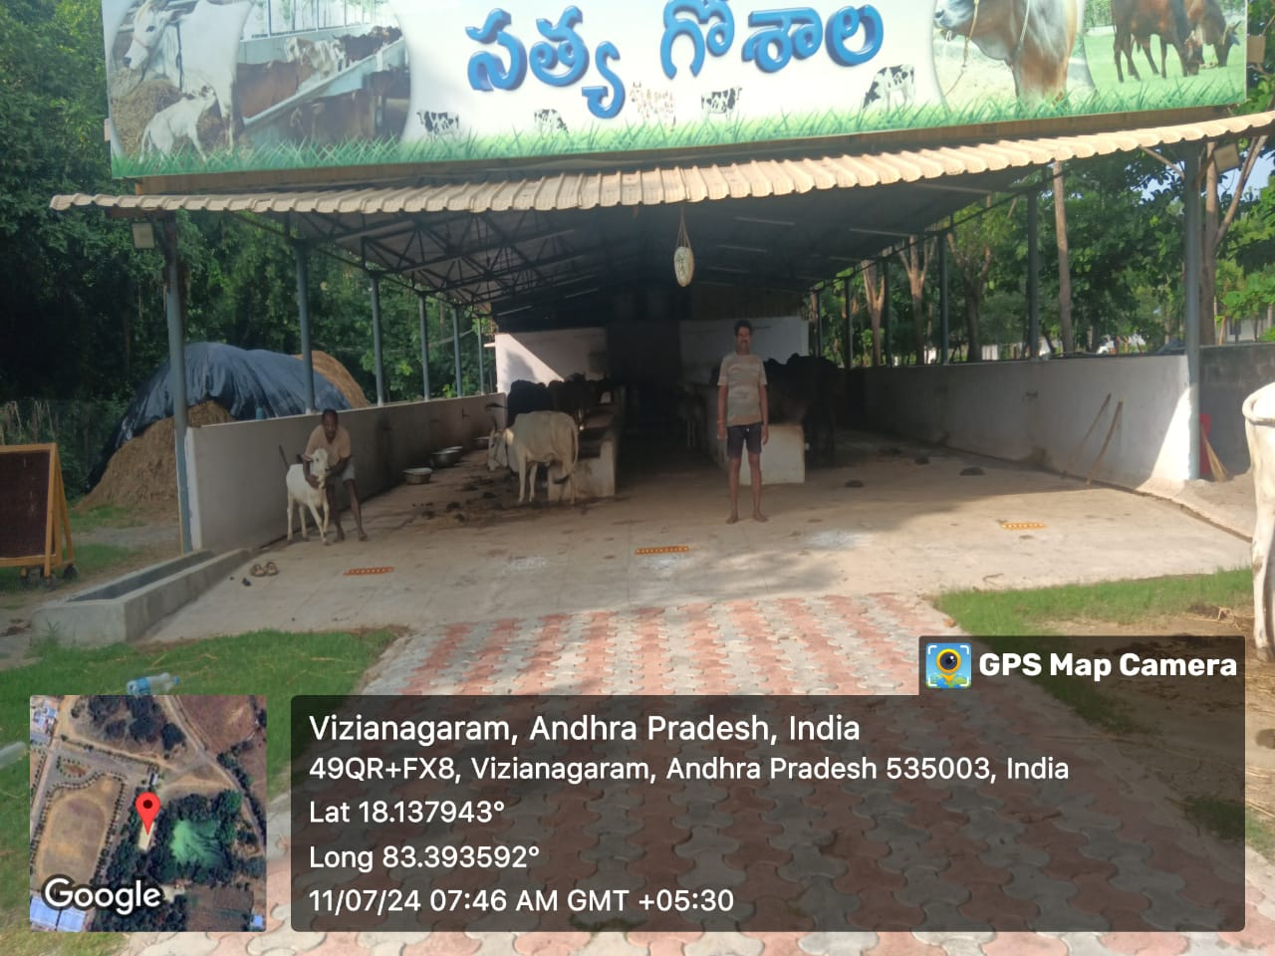
HAND BALL | 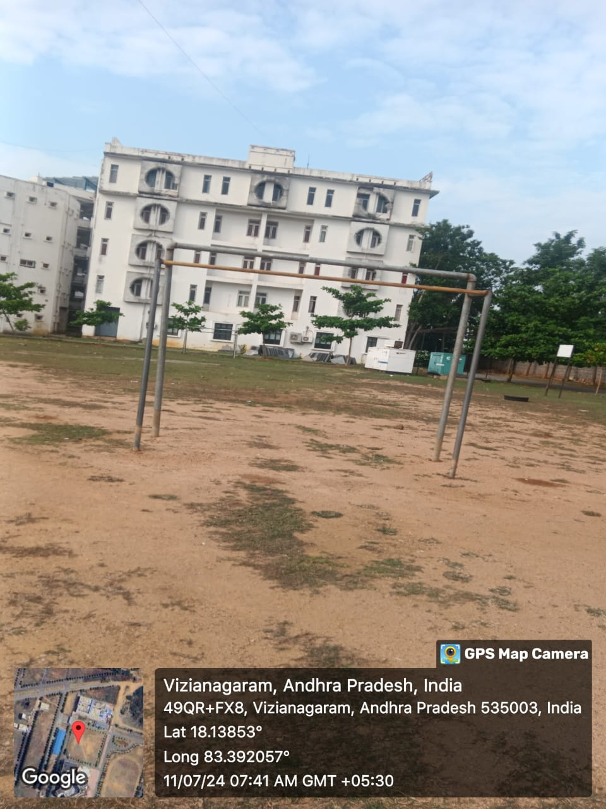
HEALTH CARE CENTER | 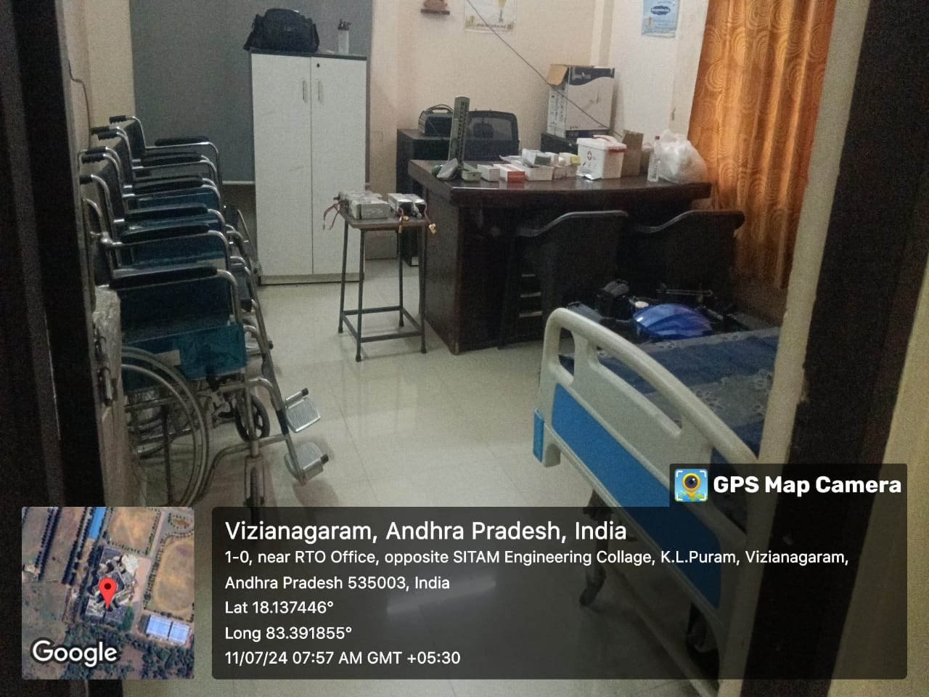
 | 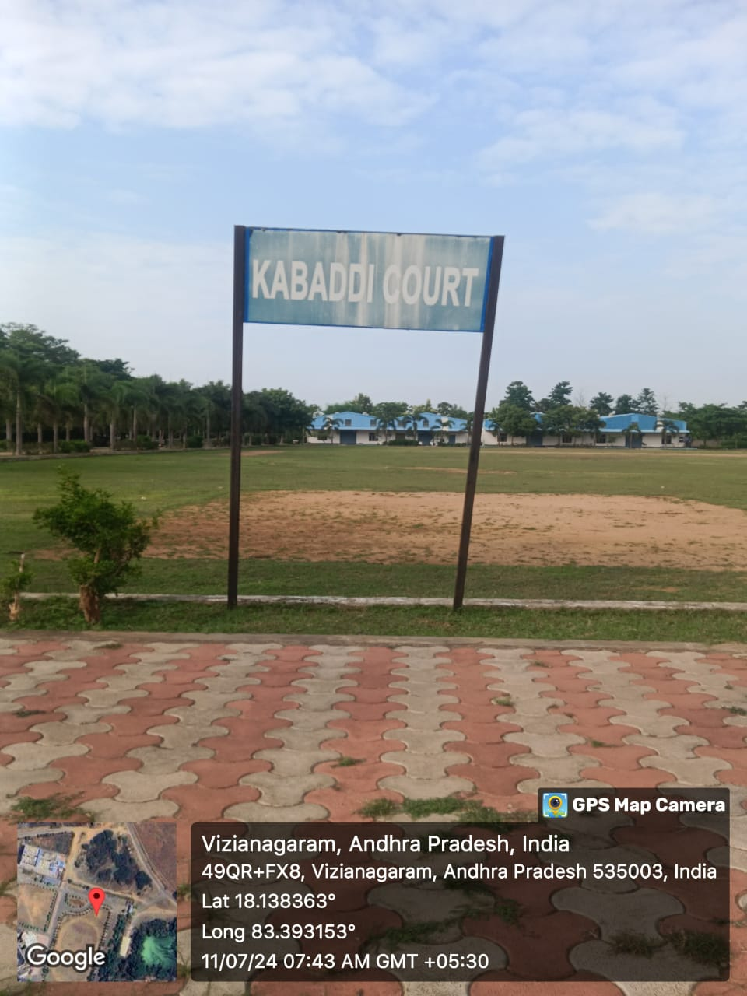
PHYSICAL EDUCATION STORE | 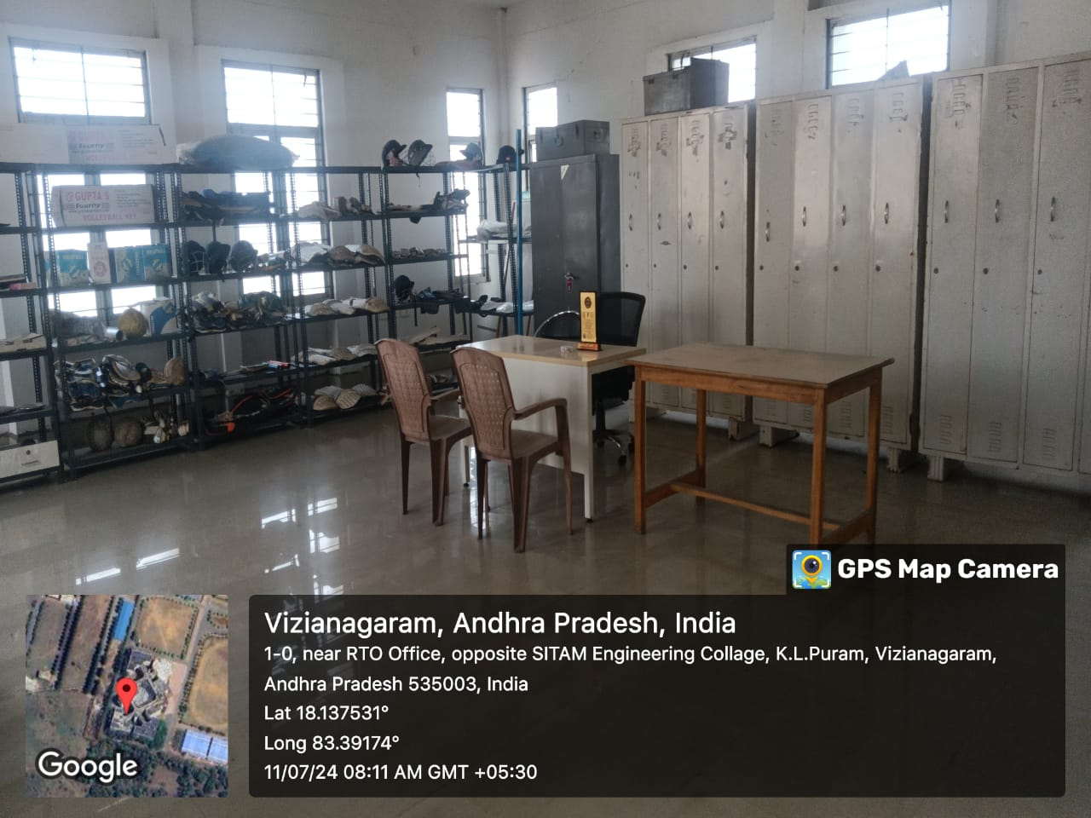
TENNI KOIT | 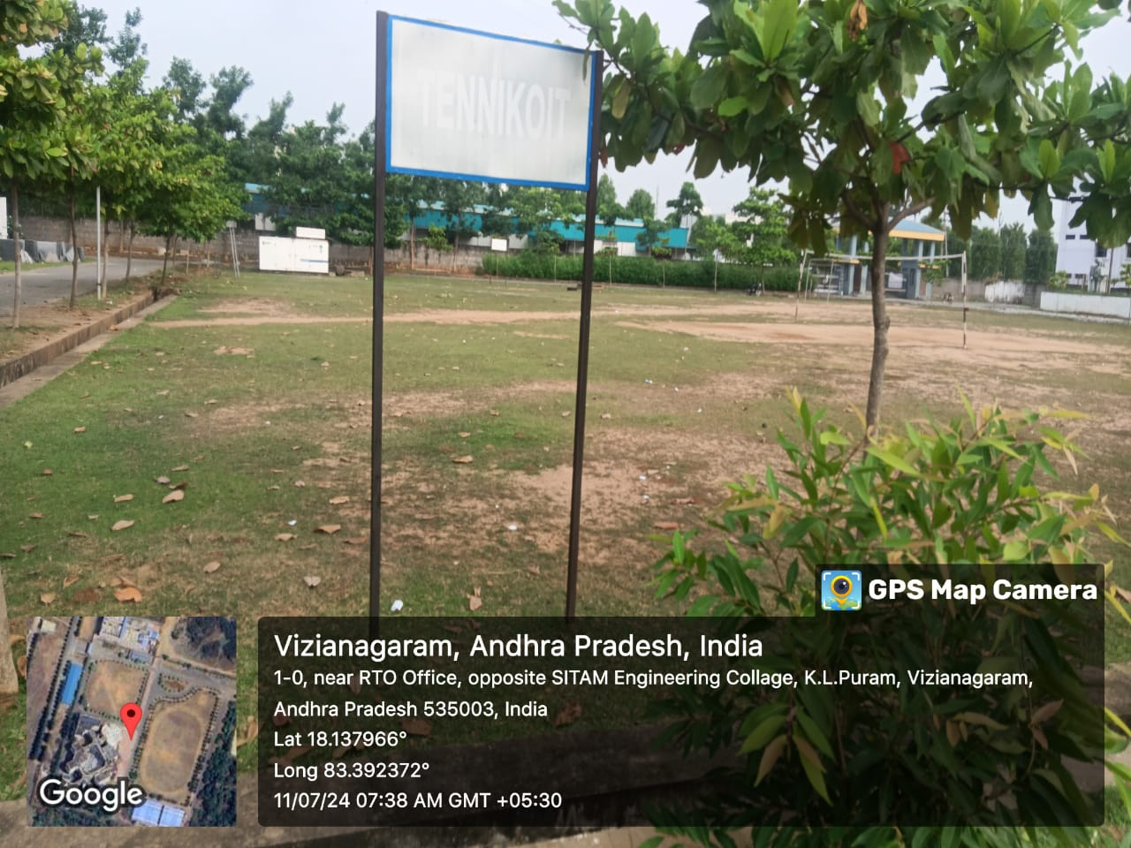
THROW BALL | 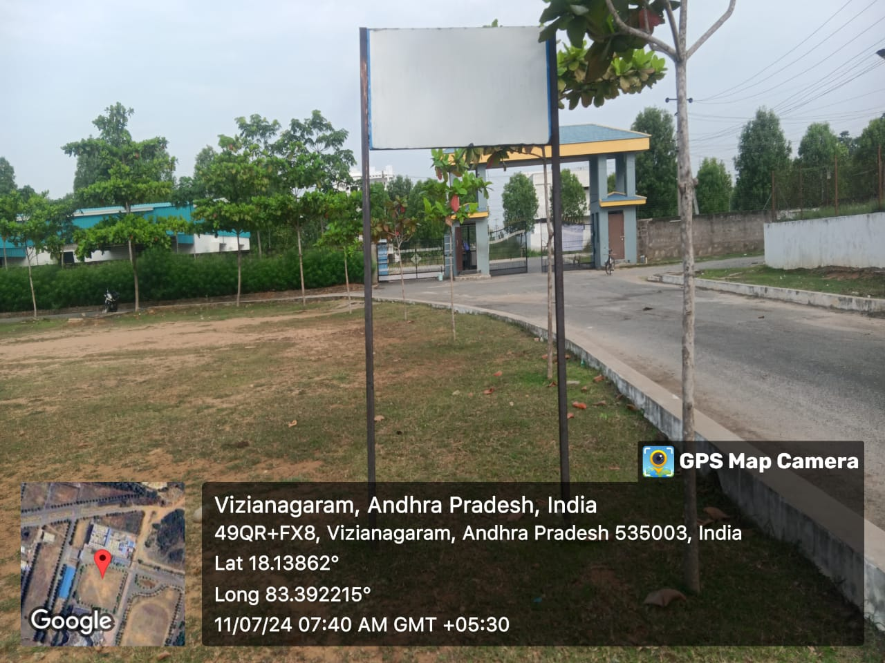
TABLE TENNIS | 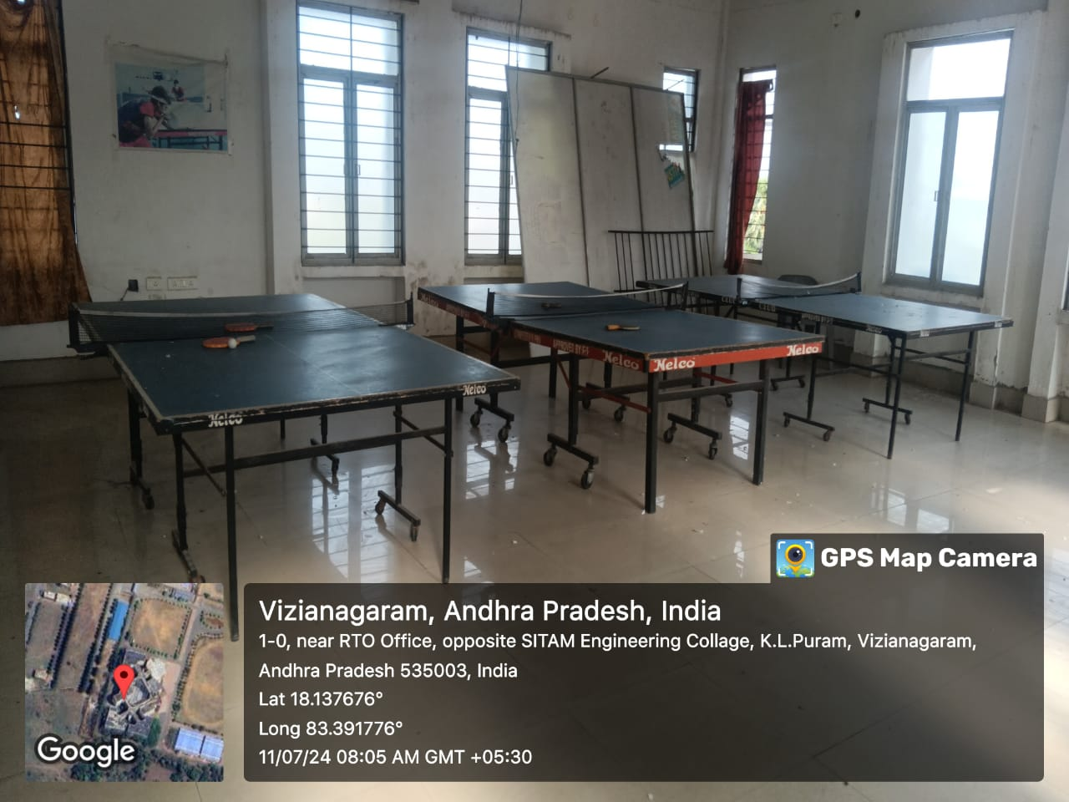
VOLLEY BALL | 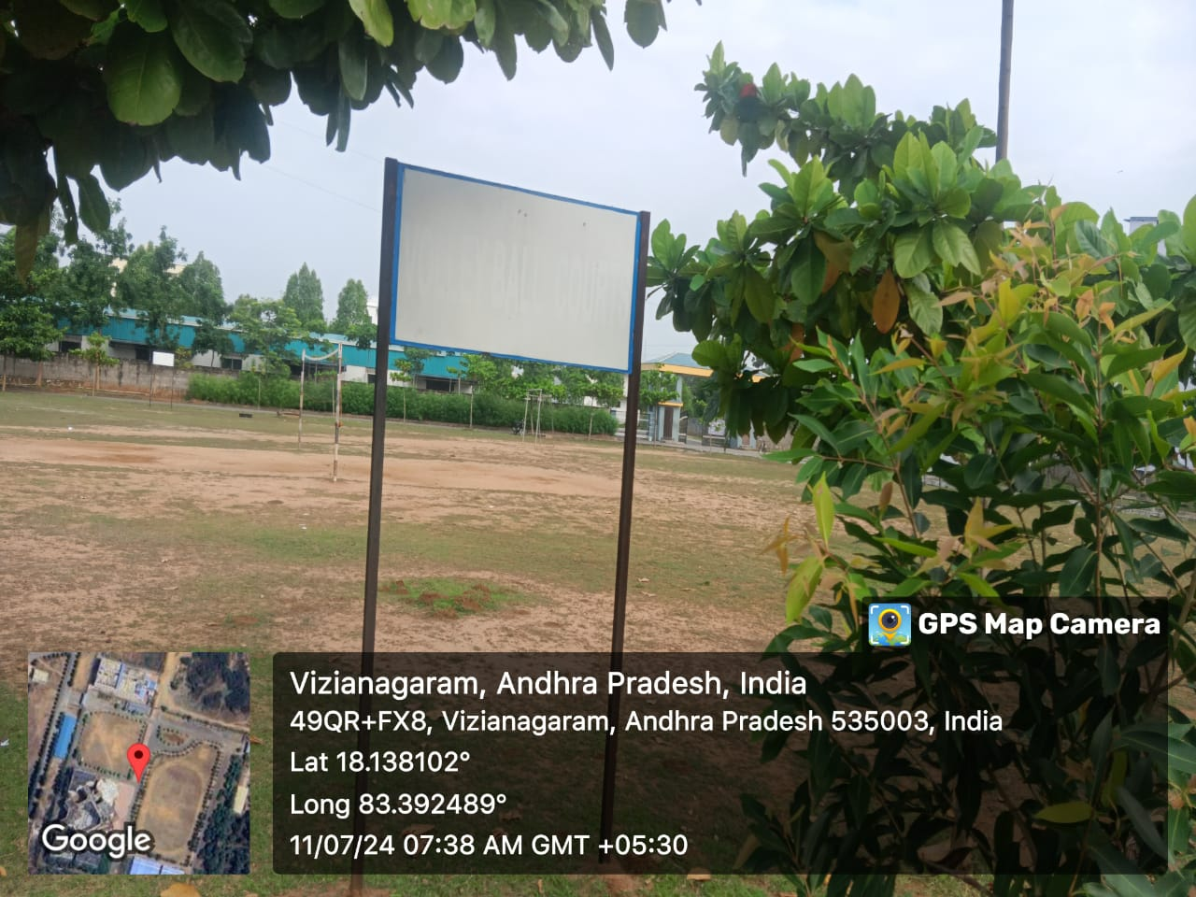
Yoga day | 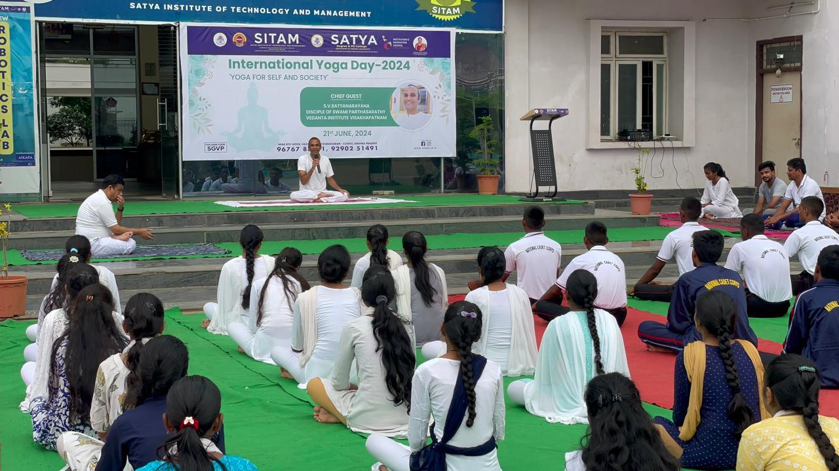

NAME:- CH. YASASWANI
YEAR & BRANCH: 3rd YEAR AI&DS (SITAM)
PARTICIPATING UNDER JNTU GURAJADA VIZIANAGARAM
COMPITATION: - ALL INDIA INTER UNIVERSTIY TAEKWONDO (MEN & WOMEN CHAPIONSHIP 2024)
VENUE:- GURUNANAK UNIVERSITY, AMRITSAR, PUNJAB (ST)
TOURNMENT DATE :- 08/11/2024 TO 17/11/2024
EVENT-1 :- KYORUGI(WEIGHT ABOVE 73 KG)
EVENT-2:- POOMSAE (BELOW 30 YEARS)
RESULT:- PARTICIPATED
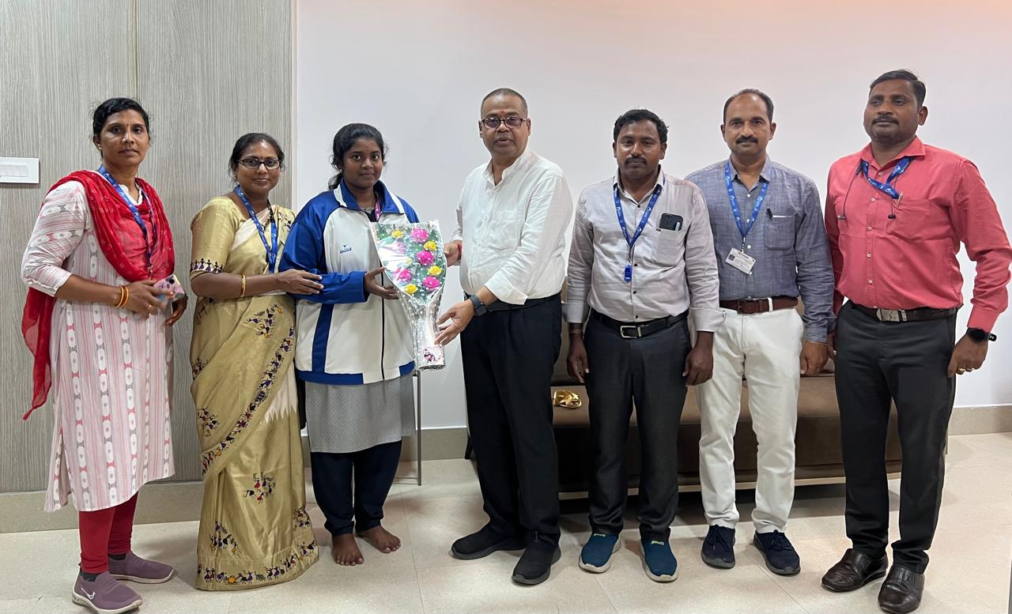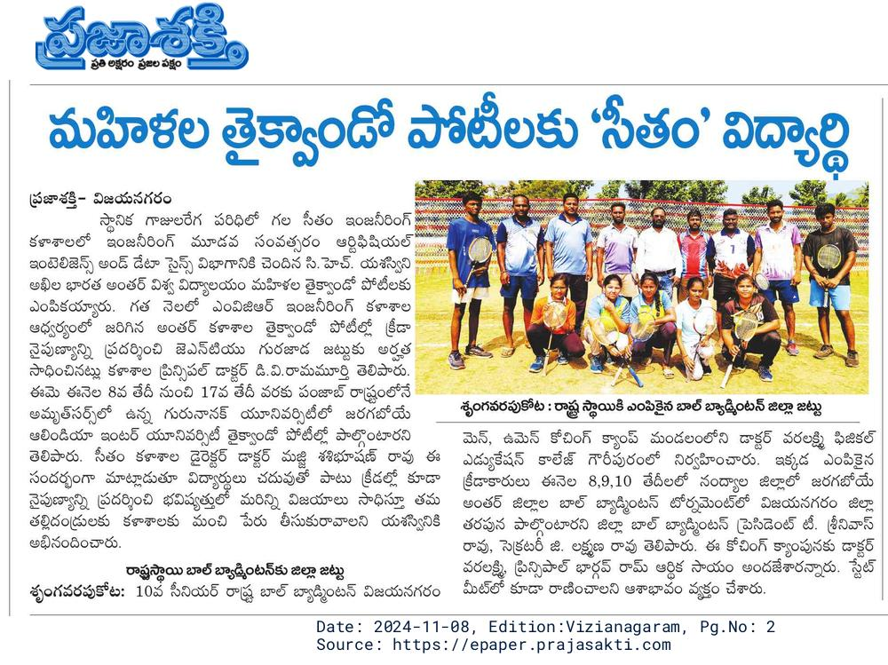

NAME:- K. JAGADISH
YEAR & BRANCH: 1st YEAR ECE (SITAM)
SITAM ENGINEERING COLLEGE, VIZIANAGARAM
COMPITATION: - 10th OPEN NATIONAL SCHOOL SPORTS CHAMPIONSHIP 2024
VENUE:- MAPUSA, NORTH GOA
TOURNMENT DATE :- 16/11/2024 TO 18/11/2024
EVENT :- BOXING UNDER 19 YEARS (WEIGHT 60-63 KG)
RESULT:- GOLD MEDAL
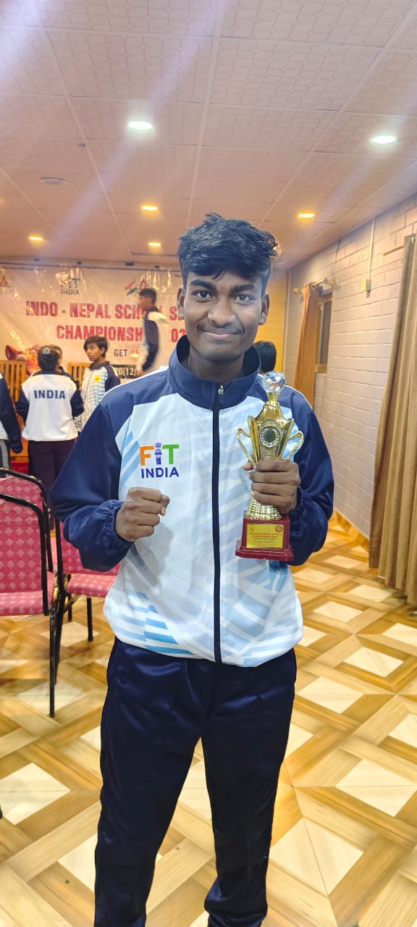

NAME:- M. SAI YASWANTH
YEAR & BRANCH: 3rd YEAR AI&DS (SITAM)
PARTICIPATING UNDER JNTU GURAJADA VIZIANAGARAM
COMPITATION: - ALL INDIA INTER UNIVERISTY CROSS COUNTRY (MEN)
VENUE:- MANGALORE UNIVERSITY, MANGALORE, KARNATAKA (STATE)
TOURNMENT DATE :- 18/11/2024 TO 19/11/2024
EVENT :-ATHLETICS CROSS COUNTRY RUN
RESULT:-PARTICIPATED

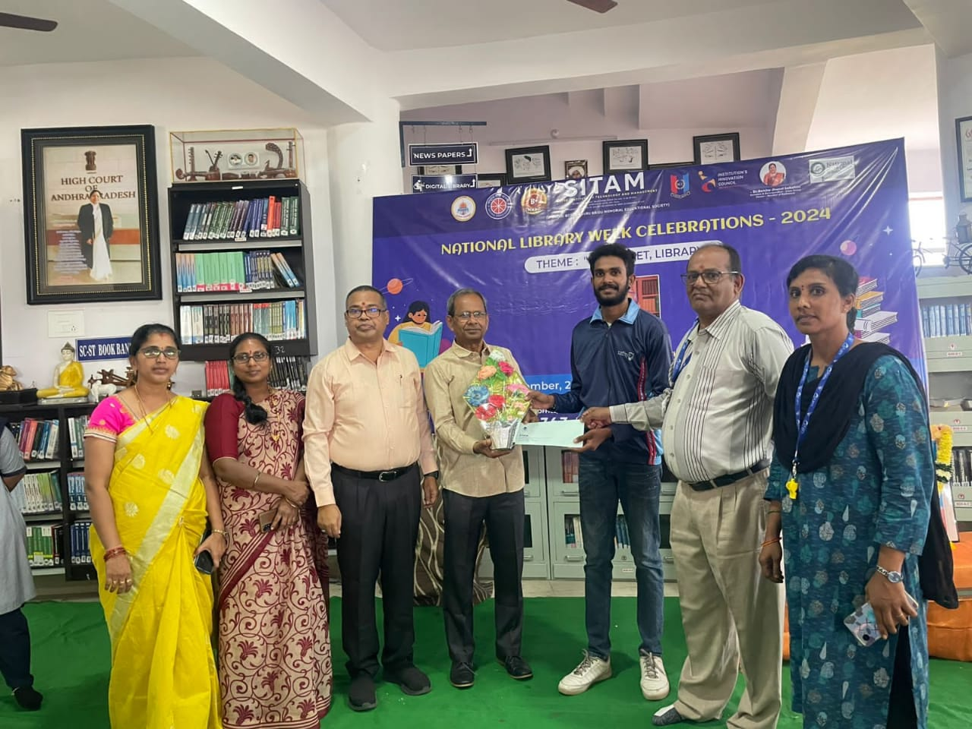

EENADU CRICKET LEAGUE TORUNMENT VIZIANAGARAM – 2024
OUR TEAM PARTICIPATED SEMI-FINAL ROUND
TOURNMENT DATE :- 29-12-2024 TO 30-12-2024
